Exposed From Within
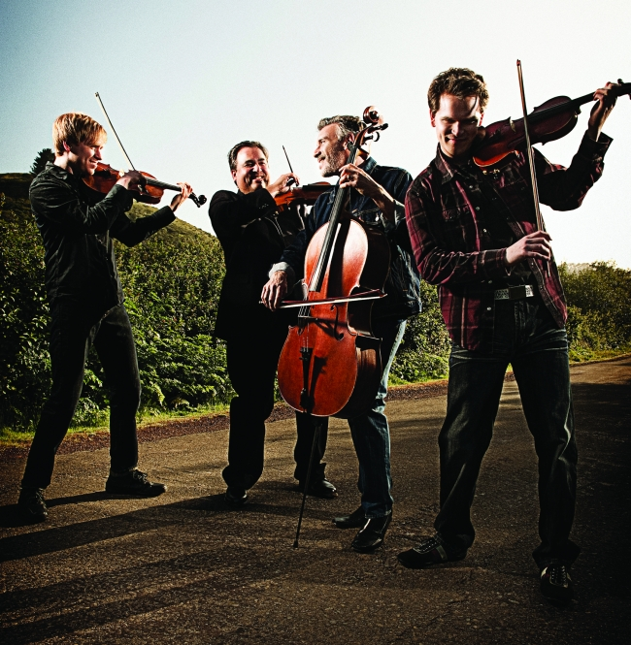
©2010 Jay Blakesberg
It starts when you hear the opening few bars of “Voodoo Child.” You think your mind – and at the very least, your ears – are playing an evil trick on you. It takes a few moments for you to pick out what exactly is happening. “Wait, is that a cello? Is that a violin? Are they playing Jimi Hendrix? What... what... is this?”
The answer: it’s The Turtle Island Quartet, and it’s outstanding. Conceived in 1985 as the brainchild of composer and violinist David Balakrishnan, with Mark Summer (cello, original member), Mads Tolling (violin) and Jeremy Kittel (viola), Turtle Island is like nothing you’ve ever heard before. That is, until they come to Tyler’s Liberty Hall on Feb. 26, of course. The group is ostensibly a string quartet, but their set list might not be what you'd expect from someone accustomed to chamber music. Each member might be classically trained, carrying the skill set and experience to have manned some of the most prestigious orchestras in the world. But these guys have chops.
“It was about 26 years ago and, David – we call him our composer in residence – had come up with this idea of an improvisational string quartet,” Summer said. “Well, all four members were equally versed in classical technique and jazz improvisation, and there really had never been a band like that.”
The group’s first recording earned a Grammy nomination for Balakrishnan, for “A Night In Tunisia.” It signaled an early recognition within the industry and their peers for merging the classical approach and instruments of chamber music with the extemporaneous nature of jazz and rock'n'roll. Plus, it’s just fun.
“There were lots of emotions,” Summer said. “David had been nominated for the first recording that came out in 1987. The first Grammy was 2006 ... and it was a wonderful feeling and very validating.”
But for the group, there was a feeling of “what’s next?” The recording with the Ying Quartet was a very clear classical crossover with Turtle Island in the role of jazz quartet. So for them, the next logical step would be to continue in the collaborative or crossover vein, specifically with the music of John Coltrane. The resulting album: “A Love Supreme: The Legacy of John Coltrane,” won the Grammy for Best Crossover Classical Album in 2008.
“That involved a tremendous amount of composition on David’s part, and a tremendous amount of work on the group’s part of making this music come alive on instruments it wasn’t originally intended for,” recalled Summer. “How do you do that? How do you make a violin sound like a saxophone? There are a lot of ways to do it, but essentially it comes from inside the player. The feeling for the music, and the understanding of vibrato and phrasing and some of these things seem so obvious to say but you’ll hear sometimes different ensembles trying this and it’s not always successful because it’s imposed from without. It’s like ‘here are these notes, read this and it sounds like rock'n'roll.’ Well,” Summer said, incredulously, “only if the players listen to rock and roll. Only if they understand how the backbeat works, only if they understand how to use vibrato and phrasing to enhance this backbeat music that makes you want to dance.”
To hear Summer explain it: “We took advantage of [the concept] what can a string quartet really do... With contemporary music... With a groove? I mean, that’s really a big thing that distinguishes us: as we’re playing, we’re playing groove-based music. We have always gotten audiences very involved, rhythmically, with what we are doing … Its music that you can really move your body to.”
Each member of Turtle Island was trained in very classical methods, but all-the-while, their passions weren’t solely given over to that style. They were listening to The Beatles, The Doors and The Rolling Stones – and even the untrained ear can hear it in their music (fairly obviously). There’s a backbeat there, a soul. It comes from not just reading the notes on paper, but having been into that music. Several times throughout our chat, Summer reiterated how intensely the group listens to the music they are working on – it’s like highly trained engineers studying the work of another in a very closely-related field. Plus, they’ve played in other bands, as well – with drums, piano, guitar. And most of them play other instruments, too – “at least enough to get myself in trouble,” joked Summer.
“I guess the thing about what Turtle Island does is that we internalize all this music by really listening to it intensively: how it works and how its put together,” explained Summers. “That is really truly what made this recording and program that we will be presenting in Tyler (“Have You Ever Been...?” the music of Jimi Hendrix). It wasn’t just like, ‘Oh great... we’ll just wig out on this rock'n'roll music.’ David’s concept was to really showcase this music and its great compositions. It was done, not so much by ink and paper, but by ... laying multiple lines of a guitar down with an overdub, which suggested the contrapuntal textures of chamber music (the general movement of melodies with respect to one another). So, he kind of transcribed some of those lines and put together versions of tunes from “Have You Ever Been To Electric Ladyland” and made a suite out of it … Then there is a lot of improvisation, as well. I’m trying to give the illusion of drums and bass (with my cello), as well... We do anything we can to fool the listener into thinking there is a full band there – but there are really just the same four instruments that Hayden used hundreds of years ago.”
And that might be the main hangup for people – if they still have one. You might know you’re about to hear some Hendrix, but it could be hard to wrap your head around four guys coming onstage with violins, a cello and a viola. The Turtle Island Quartet relishes the chance to turn those preconceived notions around with their audiences. At least they have plenty of chances. They’ve toured extensively throughout the United States, Asia and Europe – from high schools and colleges, to symphony halls and outdoor theatres.
“[Playing for people who’ve never heard this type of music] is quite a daunting task,” Summer said. “We’re playing for young people who might not have ever heard a string quartet before. And the first thing they hear us play is Jimi Hendrix and John Coltrane. We actually do a presentation for school kids called ‘The Art of the Groove,’ and we always make sure we play a little snippet of Beethoven. We say, ‘this is Beethoven, and he’s the greatest composer, and he composed so well for string quartet, but... that’s not how we like to do things.’ … But [playing outside the traditional venues for classical music] is a fantastic thing, very different than traveling in Europe where people are much more familiar with the string quartet. They are starting at a different place, but the reception that we get in different parts of the country is surprisingly robust. It’s kind of what keeps us doing this, for sure.”
Keep doing it, indeed. Turtle Island has shared records and the stage with some of the most important and talented musicians hailing from bluegrass, jazz, classical and a dozen other genres.
“We’ve collaborated with the Ying Quartet and Leo Kottke and Assad Brothers, a wonderful classical guitar duo, and Mike Marshall,” recalled Summer. “We’ve played with Cyrus Chestnut and Kenny Barron, these wonderful jazz pianists. We’ve done a lot of collaboration in the last 15 years, and we’ve got two projects coming up in the fall of 2012 and spring of 2013. One of them is with jazz singer Tierney Sutton (currently nominated for two Grammys this year for jazz vocals) called ‘Poets and Prayers’ which will feature some spiritual things and the work of Joni Mitchell. It’s still in process. So, that’s about all I can say. We’re also playing with Cajun fiddler/singer Michael Doucet, a mainstay of the group BeauSoleil – out of I think Lafayette, Louisiana. That’s a program called ‘Louisiana Story.’"
Hearing a roll call like that, it’s not really easy to pin down what it is Turtle Island actually does, surely. There have been a number of groups in recent years that have found success combining more generally popular music or songs with a certain unexpected flair or influence – jazz covers of Black Sabbath, grunge versions of 1980s dance classics. But, Turtle Creek is definitely a more genteel interpretation of the idea. You won’t be headbanging to their music, but the collaborations with some of the world’s most impressive and accomplished musicians – across a stunningly wide array of genres and styles – doesn’t fit into many molds beyond the fact that it’s very, very good. And, having been at this for 26 years, Turtle Island has the cachet to mix music with some of the best in the business and the chops to keep up, advance and innovate.
“People have this idea of going to hear a string quartet concert as being kind of still and quiet ... and our group is not like that,” said Summer. “It’s very involving rhythmically. I can’t say people are going to be dancing in the aisles, but they’ll be tapping their feet in their seats. And I think that’s a new experience for people regarding string quartets.”

